SharePoint Brainstorm

For this SharePoint site for the CIS Department, the information should include the department overview of the website, homepage of the website, blogs that shows stories from web authors, FAQ page that shows questions and answers, About Us page that talks about the purpose of the website, a Contact page that shows the link of social media sites, news updates too keep up with the content, and events calendar that can show information about the upcoming events, feedback and support site, and the courses page. In addition to the pages, it must be visually appealing with some photos that help represent the website.

Here is the sketch wireframe of what the website was supposed to look like or would look like.

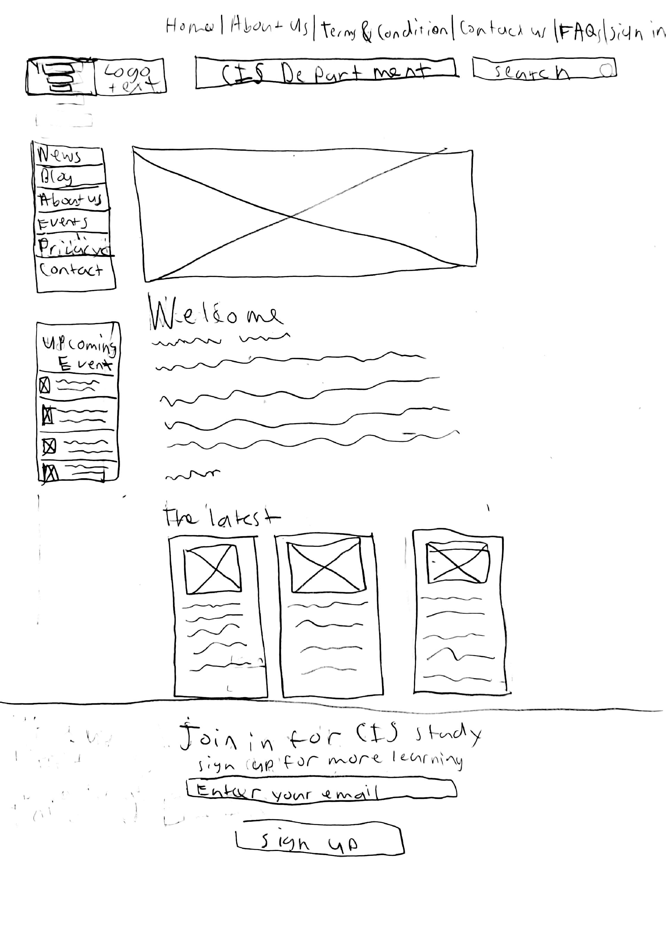

Courses

Note: I had to do it on paper, so I apologize if my drawing feels rusty. Also, I placed the text that reads “Course” to cover up “Privacy” for what would the task bar looks like.

Considering that this is the first time using SharePoint, I would like to learn more about the navigation interface of this collaboration tool, customizing and integrating tools of the, creating lists and libraries of my work, setting up site permissions, and creating functioning workflows that can automate business processes. The plan to learn all these SharePoint topics is to start with the beginner’s tutorial for basic understanding or experiment with creating sites, libraries, lists, and workflows until I start to get used to it. Another plan is to utilize Microsoft Learn platform for an official guide to SharePoint or watch SharePoint training videos that are provided by Microsoft Support group. However, this is a group project, so the possible plan is to participate in a discussion platform within class emails or through possible social media platforms like Discord.

The theme of the website I would use is After School so that it could be visually appealing to the topic of the department project.

This is the first time using SharePoint and I am not sure how this project would go, but of course it is a group project, I will do my best for the group.